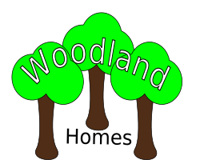

The Spinney
Greenlands
Foreston
Barkshire
FF2 9OF
0115-496 0377

«Title» «FamilyName»
«Address»
«CityTown»
«Post_Code»

Dear «GivenName»,
Thank you for your interest in Woodland Homes.
We regret there are no single apartments available at the moment.
Please ring the office to arrange a viewing.

Regards,
Name Surname, XXXXX, XXXX

